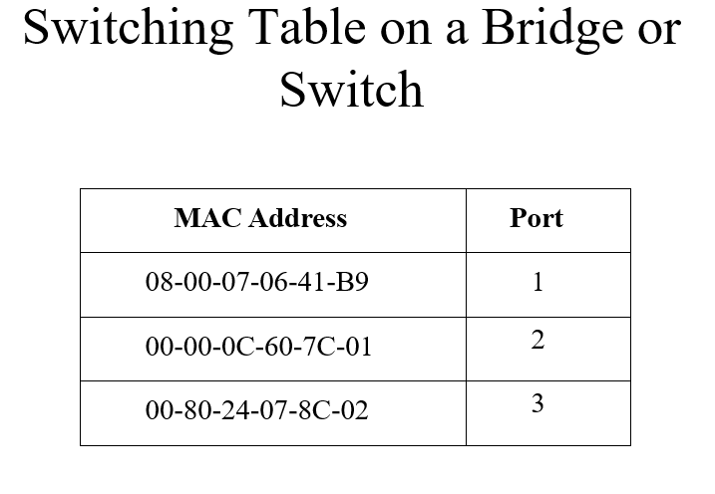
Figure 1
Answer all of the questions based on the switching table in Figure 1 above. Apply this concept to your lab activity now.

Question 1
Explain what actions a switch will take when it receives a frame with a destination MAC address that is not currently listed in its switching table. What is the technical name for this process?
Question 2
Using the provided "Switching Table on a Bridge or Switch" diagram, describe exactly how the switch will handle a frame if a host connected to Port 1 sends data intended for the MAC address 00-80-24-07-8C-02.
Question 3
How does a transparent bridge or switch dynamically learn and populate its switching table without manual configuration by an administrator?
Question 4
The slides mention that a switch will "Flood broadcasts and multicasts". Contrast how a switch handles a Broadcast frame versus a Known Unicast frame (a unicast address already present in the table).
Question 5
What is the primary benefit of the "Filter frames from going out ports that don’t include the destination address" task in terms of network performance?

